Segment address - add zero to the left most side

Zero – offset address (IP – Instruction Pointer)

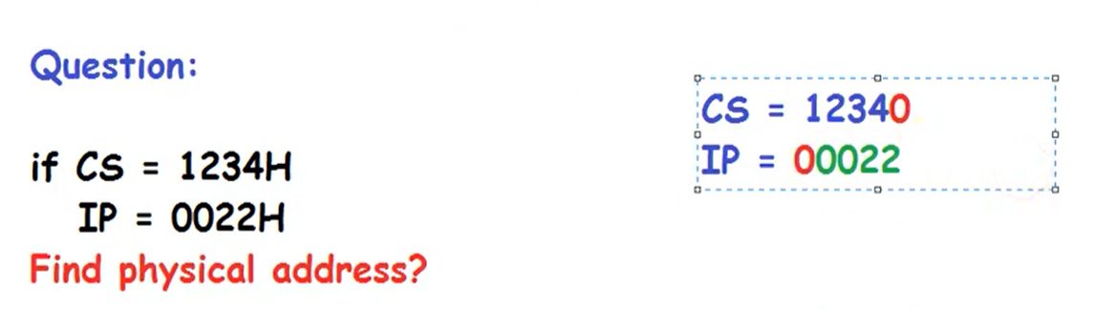

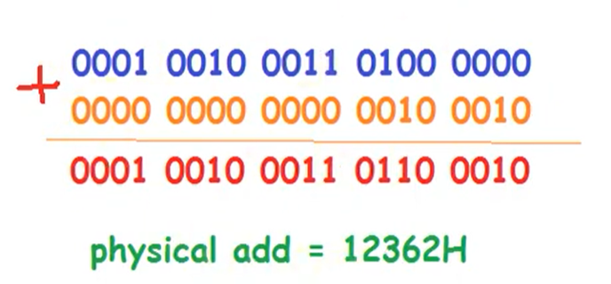

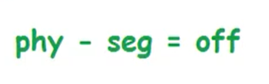

Added zero at the end of segment address

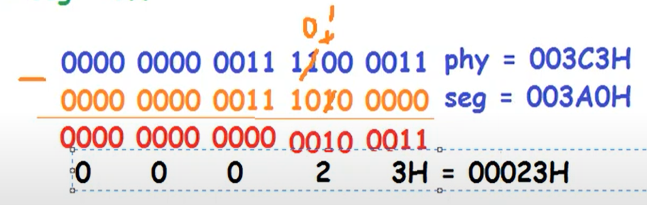

Remember that we always add a zero to the left most side of the offset number, now when we have the offset number, we will remove the left most zero.

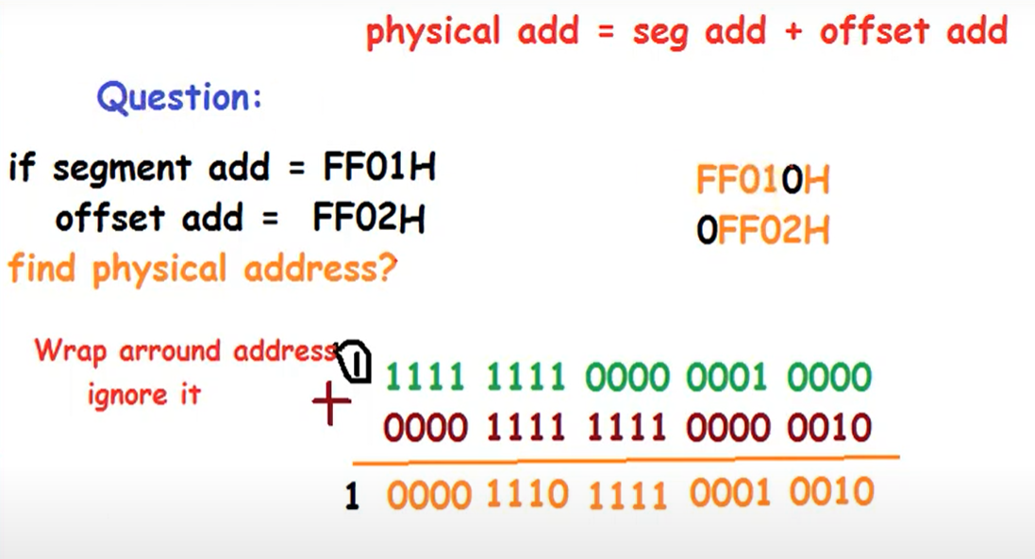

**What are the first and the last physical memory addresses accessible using the following segment values?**

a. 1000

b. 0FFF

c. 1002

d. 0001

e. E000

In x86 architecture, the physical address is calculated using the formula:

Physical Address = (Segment Base × 16) + Offset

This formula makes the segment shift 4-bits to the left

The segment values provided are used as segment bases in this calculation. To find the first and last physical memory addresses accessible with each segment value, we'll assume an offset range of 0x0000 to 0xFFFF (which covers the full 64KB range for each segment).

**Calculation Method**

1. **First Physical Address**: This is calculated using the offset 0x0000.
2. **Last Physical Address**: This is calculated using the offset 0xFFFF.

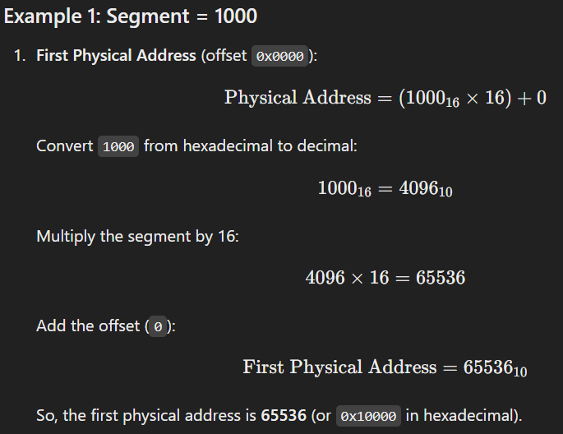

Add Hexadecimal:  
F + F = 30

30 – 16 = E + (carry 1 to the left)

|  |  |  |  |  |  |
| --- | --- | --- | --- | --- | --- |
| Carry | 1 | 1 | 1 |  |  |
| Hex 1 |  | F | F | F | 0 |
| Hex 2 |  | F | F | F | F |
| Answer | 1 | F | F | E | F |